Program 1: Simple Signal Handler — SIGINT

#include <stdio.h>
#include <signal.h>
#include <unistd.h>

void handle_signal(int sig)
{
printf("\nSIGINT received!\n");
}
int main()
{
signal(SIGINT, handle_signal);

while (1)
{
printf("Program is running...\n"); sleep(2);
}
return 0;
}
gcc signal1.c -o signal1 ./signal1
Output:
Program is running...
Program is running...
Program is running...
Now press:
Ctrl + C
You can see: SIGINT received!
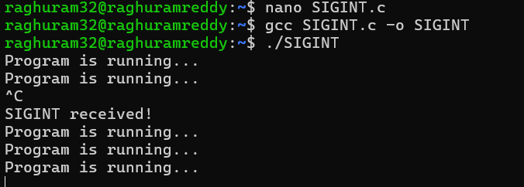

Program 2: SIGINT Without a Handler
#include <stdio.h> #include <unistd.h> int main()
{ while (1)
{
printf("Program is running...\n"); sleep(2);
}
return 0;
}
Run: ./signal2
Press:
Ctrl+C
The program terminates.
Program 3: SIGCHLD - Child Process Signal SIGCHLD is related to parent-child processes. When a child terminates, the parent can receive SIGCHLD.
#include <stdio.h>
#include <signal.h>
#include <unistd.h> #include <sys/wait.h> void handle_sigchld(int sig)
{
printf("SIGCHLD received: Child has terminated.\n");
}
int main()
{
signal(SIGCHLD, handle_sigchld);
pid_t pid = fork(); if (pid == 0)
{
// Child printf("Child is running...\n"); sleep(3); printf("Child is terminating...\n"); } else
{
// Parent printf("Parent is waiting...\n"); wait(NULL); printf("Parent finished.\n");
}
return 0;
}
Output:
Parent is waiting...
Child is running...
Child is terminating...
SIGCHLD received: Child has terminated.
Parent finished.
Note: As signals are asynchronous, the messages' order may vary.
SIGCHLD does not mean "kill the child." It means:
The state of a child process has changed. Commonly, the child has terminated.
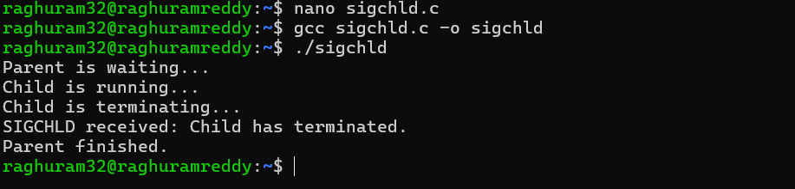

Program 4 - SIGPIPE - Broken Pipe
- This one connects directly to the pipes you have already learned. SIGPIPE occurs when a process tries to write to a pipe after all readers have closed the read end.
- SIGPIPE tells the writer that it is trying to write to a pipe whose read end has been closed.

#include <stdio.h> #include <unistd.h> int main()
{ int fd[2]; pipe(fd); close(fd[0]); // Close read end printf("Writing to pipe...\n"); write(fd[1], "Hello", 5); printf("Write completed.\n"); return 0;
}
Output
Writing to pipe...
Then the process terminates because write() generates a SIGPIPE signal.
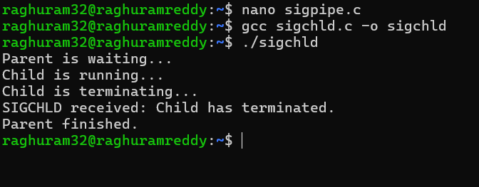
So:
Writing to pipe...
Broken pipe

Program 5 - kill() program
In Linux, kill() is used to send a signal to a process.

Despite its name, kill() does not always mean "kill the process."

kill(getpid(), SIGUSR1) - means Send SIGUSR1 to process pid.

Parent sends signal to child Program

#include <stdio.h>
#include <signal.h>
#include <unistd.h> #include <sys/wait.h> void handler(int sig)
{
printf("Child received SIGUSR1\n");
}

int main()
{ pid_t pid = fork(); if (pid == 0)
{
// Child
signal(SIGUSR1, handler); printf("Child waiting...\n"); while (1)
{ sleep(1);
}
} else
{
// Parent sleep(2); printf("Parent sending signal...\n"); kill(pid, SIGUSR1); sleep(2); kill(pid, SIGTERM); wait(NULL);
}
return 0;
}

Output :
Child waiting
Parent sending signal
Child received SIGUSR1
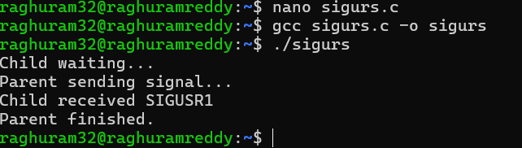

Program 6 - SIGABRT — Abort

This is commonly generated when a program calls:

#include <stdio.h>
#include <stdlib.h>

int main()
{
printf("Program started\n"); abort(); printf("Program ended\n"); return 0;
}

Output:

Program started

Then the program terminates.

This line printf("Program ended\n"); is not executed.
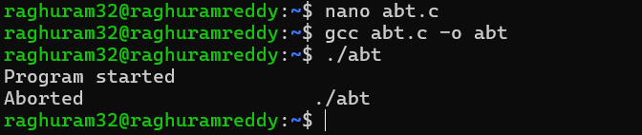

Program 7: SIGSEGV - Invalid Memory Access

This is an important signal for understanding segmentation faults. #include <stdio.h> int main()
{
int *p = NULL; printf("Before error\n");
*p = 10; printf("After error\n"); return 0;
}

Output:

Before error
Segmentation fault

Note: The program tries to access invalid memory: *p = 10
